**OPTINSIGHT: REVOLUTIONIZING OPHTHALMIC CARE WITH DEEP LEARNING FOR PREDICTIVE EYE DISEASE ANALYSIS**

AN INDUSTRY ORIENTED MINI REPORT

Submitted to

## JAWAHARLAL NEHRU TECNOLOGICAL UNIVERSITY, HYDERABAD

In partial fulfillment of the requirements for the award of the degree of

## BACHELOR OF TECHNOLOGY

## In

## COMPUTER SCIENCE AND ENGINEERING (DATA SCIENCE)

Submitted By

## MOHAMMED ABDUL RASHEED KHALID 21UK1A6769

## MOHAMMAD SUBHAN 21UK1A6768

## MODEYA RITHVIK KUMAR 21UK1A6766

## SANGA RAKESH 22UK5A6714

Under the guidance of

## Mr. E.MAHESH

Assistant Professor



**DEPARTMENT OF COMPUTER SCIENCE AND ENGINEERING VAAGDEVI ENGINEERING COLLEGE**

Affiliated to JNTUH, HYDERABAD BOLLIKUNTA, WARANGAL (T.S) – 506005

**DEPARTMENT OF**

**COMPUTER SCIENCE AND ENGINEERING( DATA SCIENCE )**

**VAAGDEVI ENGINEERING COLLEGE(WARANGAL)**



**CERTIFICATE OF COMPLETION INDUSTRY ORIENTED MINI PROJECT**

This is to certify that the UG Project Phase-1 entitled “OPTINSIGHT: REVOLUTIONIZING OPHTHALMIC CARE WITH DEEP LEARNING FOR PREDICTIVE EYE DISEASE ANALYSIS “is being submitted by MOHAMMED ABDUL RASHEED KHALID(21UK1A6769), MOHAMMAD SUBHAN(21UK1A6768), MODEYA RITHVIK KUMAR(21UK1A6766),SANGA RAKESH(22UK5A6714),

in partial fulfillment of the requirements for the award of the degree of Bachelor of Technology in Computer Science & Engineering to Jawaharlal Nehru Technological University Hyderabad during the academic year 2023- 2024.

## Project Guide HOD

## Mr. E. MAHESH Dr.K.Sharmila

(Assistant Professor) (professor)

**External**

**ACKNOWLEDGEMENT**

We wish to take this opportunity to express our sincere gratitude and deep sense of respect to our beloved **Dr.P.PRASAD RAO,** Principal, Vaagdevi Engineering College for making us available all the required assistance and for his support and inspiration to carry out this UG Project Phase-1 in the institute.

We extend our heartfelt thanks to **Dr.K.SHARMILA**, Head of the Department of CSE, Vaagdevi Engineering College for providing us necessary infrastructure and thereby giving us freedom to carry out the UG Project Phase-1.

We express heartfelt thanks to Smart Bridge Educational Services Private Limited, for their constant supervision as well as for providing necessary information regarding the UG Project Phase-1 and for their support in completing the UG Project Phase-1.

We express heartfelt thanks to the guide, **E.MAHESH,** Assistant professor, Department of CSE for his constant support and giving necessary guidance for completion of this UG Project Phase-1.

Finally, we express our sincere thanks and gratitude to my family members, friends for their encouragement and outpouring their knowledge and experience throughout the thesis.

**MOHAMMED ABDUL RASHEED KHALID (21UK1A6769), MOHAMMAD SUBHAN (21UK1A6768), MODEYA RITHVIK KUMAR (21UK1A6766), SANGA RAKESH (22UK5A6714).**

**ABSTRACT**

This project uses deep learning to address eye disease detection and demographic analysis. The **Optiinsight** system applies CNNs to retinal images for early diagnosis of conditions like diabetic retinopathy and glaucoma. The **Age and Gender Detection** model uses ResNet50 to classify age and gender from facial images. Both models show high accuracy and scalability, offering innovative solutions for healthcare and demographic analysis.

**TABLE OF CONTENTS**

1. Introduction
   1. Project overviews
   2. Objectives
2. Project Initialization and Planning Phase
   1. Define Problem Statement
   2. Project Proposal (Proposed Solution)
   3. Initial Project Planning
3. Data Collection and Preprocessing Phase
   1. Data Collection Plan and Raw Data Sources Identified
   2. Data Quality Report
   3. Data Preprocessing
4. Model Development Phase
   1. Model Selection Report
   2. Initial Model Training Code, Model Validation and Evaluation Report
5. Model Optimization and Tuning Phase
   1. Tuning Documentation
   2. Final Model Selection Justification
6. Results
   1. Output Screenshots
7. Advantages & Disadvantages
8. Conclusion
9. Future Scope
10. Appendix.

# Optiinsight: Revolutionizing Ophthalmic Care With Deep Learning for Predictive Eye Disease Analysis

**1.Introduction :**

The increasing prevalence of eye diseases such as glaucoma, cataracts, and diabetic retinopathy poses significant challenges to global healthcare. Early diagnosis and intervention can drastically improve patient outcomes, but traditional diagnostic methods often require specialized equipment and skilled personnel, limiting accessibility in underserved areas.

Optiinsight aims to bridge this gap by leveraging deep learning technologies to predict eye diseases based on retinal images. This project involves developing a robust predictive model trained on extensive ophthalmic datasets, capable of identifying early signs of common eye conditions with high accuracy. This system enhances accuracy and efficiency in demographic analysis, paving the way for smarter, AI-driven solutions. Its real-time processing capabilities make it ideal for integration into modern applications and industries.

* 1. **Project Overviews :**

Optiinsight is an AI-driven healthcare solution designed to assist in the early detection of eye diseases. Using deep learning techniques, the system analyzes retinal images to predict conditions such as glaucoma, cataracts, and diabetic retinopathy. The project involves building and training a convolutional neural network (CNN) on diverse ophthalmic datasets to ensure accurate and reliable predictions.  
The model’s architecture focuses on identifying minute patterns in retinal scans, enabling the early diagnosis of diseases. By implementing this tool, Optiinsight aims to bridge the gap in ophthalmic care, particularly in regions lacking specialized resources, and significantly reduce preventable blindness rates worldwide.

1. **Project Goals** 
   * **Personalization**: Tailored to empower healthcare providers in underserved regions by providing cost-effective diagnostic support.
   * **User Engagement** Optiinsight engages users with an intuitive interface for instant retinal image analysis and diagnostic reports. It also offers patients preventive care suggestions and awareness modules tailored to their risk factors.
   * **Diverse Suggestions**: Provides targeted strategies and demographic-based recommendations for various industries.
2. **Scalability**: Scalable for integration into hospitals, clinics, and telemedicine platforms worldwide.
   * **User Profile Creation**:

o The system collects user preferences based on demographic predictions and integrates with accounts (e.g., social media or e-commerce) for a personalized experience

* **Conversational Interface**:

o The system can engage with users through a conversational interface, responding to queries such as "What are the early signs of glaucoma?" or "Suggest preventive measures for diabetic retinopathy." This feature enhances user interaction and provides instant, relevant information.

* **Recommendation Engine**:

o The system uses machine learning techniques such as collaborative filtering and content-based filtering to recommend personalized treatment plans and preventive measures. It can leverage medical datasets and patient history to offer tailored health advice and early diagnosis predictions.

* 1. **Objectives :**

1. **Early Detection of Eye Diseases:**Develop a deep learning-based system that analyzes retinal images for the early detection of common eye diseases such as glaucoma, cataracts, and diabetic retinopathy, aiming to improve diagnosis accuracy and reduce blindness.
2. **Personalized Treatment Recommendations:**Leverage AI to provide personalized treatment plans and preventive care suggestions based on individual patient data, risk factors, and disease progression**.**
3. **Improve Accessibility to Healthcare:**Design an accessible platform that enables healthcare professionals in remote or underserved areas to quickly assess eye health through automated disease prediction, eliminating the need for specialized equipment.
4. **Enhance Healthcare Workflow Efficiency:**Streamline the diagnostic process by automating the analysis of retinal images, reducing the burden on healthcare professionals and ensuring timely intervention.
5. **Integrate with Existing Medical Systems:**Ensure compatibility with Electronic Health Records (EHR) and telemedicine platforms to allow seamless integration and data sharing across healthcare systems for a more efficient, holistic approach to patient care.

4o mini

**Top of Form**

**Bottom of Form**

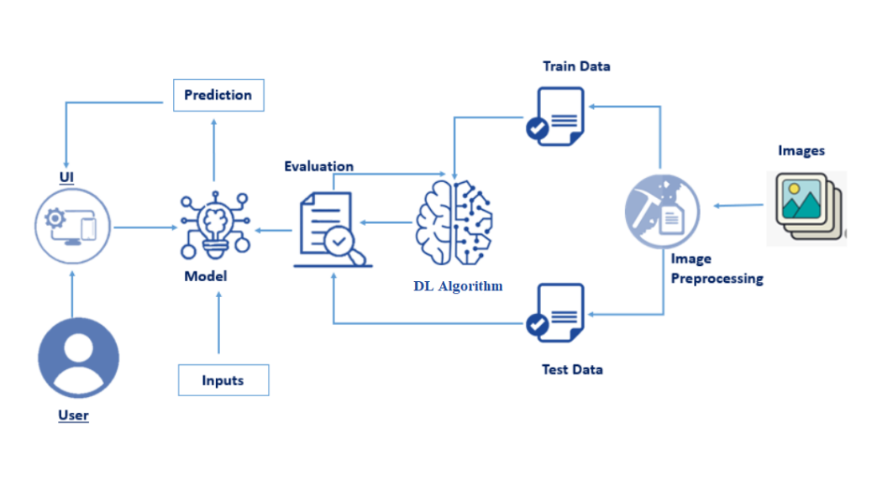

**2.Project Initialization and Planning Phase :**

**Project Vision and Goals**

1. **Define Project Scope and Objectives:**Clearly outline the goals of the project, including early detection of eye diseases, personalized treatment recommendations, and improving accessibility to healthcare, ensuring all stakeholders understand the project’s purpose.
2. **Research and Data Collection:**Gather relevant medical datasets, such as retinal image repositories, ophthalmic health records, and disease-specific datasets. Research current diagnostic methods to identify gaps that Optiinsight can fill using AI and deep learning.
3. **Identify Key Stakeholders and Roles:**Identify the team members, including data scientists, ophthalmologists, software developers, and project managers, and define their roles in the project. Establish a communication plan to ensure smooth collaboration**.**
4. **Technology Stack Selection:**Choose the appropriate technologies and tools, including deep learning frameworks (e.g., TensorFlow, PyTorch), image processing tools, and database management systems to build the predictive model and user interface**.**
5. **Timeline and Milestone Planning:**Create a detailed timeline for the project, breaking it down into key phases: data collection, model development, system integration, testing, and deployment. Set clear milestones and deadlines to track progress.
6. **Risk Assessment and Mitigation Strategy:**Identify potential risks such as data quality issues, model performance challenges, and integration problems. Develop strategies to mitigate these risks, such as rigorous data cleaning processes and regular testing**.**
7. **Resource Allocation:**Allocate resources, including hardware for model training (GPUs, cloud computing), software tools, and human resources needed for each phase of the project.
8. **Budget Planning:**Estimate the project’s budget, covering costs for data acquisition, software licenses, hardware, and team salaries. Ensure that there is sufficient funding for unexpected challenges.
9. **Regulatory and Compliance Considerations:**Ensure the project adheres to relevant healthcare regulations and standards (such as HIPAA for patient data privacy) and ethical considerations regarding AI usage in healthcare.

**2.1 Define Problem Statement:**

The prevalence of eye diseases such as diabetic retinopathy, glaucoma, and cataracts is increasing globally, leading to significant health complications, including blindness. However, early detection of these diseases is often challenging due to the limitations of traditional diagnostic methods, which require specialized equipment, skilled personnel, and can be time-consuming. In underserved areas, access to such resources is even more limited, further exacerbating the problem.

The current diagnostic process is also often delayed, resulting in the progression of eye diseases to advanced stages, making treatment more difficult and costly. There is a need for an efficient, accessible, and scalable solution to detect eye diseases early, reduce the burden on healthcare professionals, and improve patient outcomes.

Optiinsight aims to address this problem by utilizing deep learning and AI to analyze retinal images and provide accurate, early predictions of eye diseases. By automating the diagnostic process, Optiinsight enhances accessibility, provides personalized treatment recommendations, and empowers healthcare professionals to make faster and more informed decisions.

**Key Problems Addressed:**

**Early Detection of Eye Diseases:**  
Many eye diseases are diagnosed at later stages due to a lack of early symptoms or delayed medical intervention. Optiinsight addresses this by providing early and accurate predictions, enabling timely treatment and prevention of blindness.

**Limited Access to Specialized Ophthalmic Care:**  
In underserved areas, there is a shortage of trained ophthalmologists and advanced diagnostic equipment. Optiinsight offers an accessible solution by utilizing deep learning to analyze retinal images, making eye disease detection available to healthcare providers worldwide, even in remote regions.

**High Cost and Time Constraints in Traditional Diagnostics:**  
Traditional diagnostic methods can be costly, time-consuming, and require specialized skills. Optiinsight reduces the need for expensive equipment and skilled personnel by automating the analysis process, making diagnostics more affordable and efficient.

**Healthcare Workflow Bottlenecks:**  
The diagnostic process in ophthalmology can be slow and burdened by high volumes of patients. By automating retinal image analysis, Optiinsight streamlines the workflow, enabling healthcare providers to diagnose and treat more patients effectively.

**Lack of Personalized Treatment Recommendations:**  
Current diagnostic methods may not provide tailored treatment plans. Optiinsight personalizes the recommendations based on individual patient data, risk factors, and disease progression, improving the accuracy and effectiveness of treatment plans.

**Inconsistent Diagnostic Accuracy:**  
Human error and inconsistencies in manual diagnosis can lead to misdiagnosis. Optiinsight leverages AI for more consistent and reliable analysis, reducing the potential for errors and increasing diagnostic accuracy.

**2.2 Project Proposal (Proposed Solution):**

Optiinsight proposes a deep learning-based solution for the early detection of common eye diseases, such as diabetic retinopathy, glaucoma, and cataracts, by analyzing retinal images. The system will leverage artificial intelligence and machine learning algorithms to accurately predict eye diseases at their earliest stages, providing healthcare professionals with essential insights for timely intervention.

**Key Features of the Proposed Solution:**

1. **Deep Learning Model for Retinal Image Analysis:**  
   The core of Optiinsight will be a convolutional neural network (CNN) trained on a large dataset of retinal images. This model will be capable of identifying patterns and anomalies indicative of eye diseases, including subtle signs that are difficult to detect by human experts.
2. **Personalized Treatment and Preventive Recommendations:**  
   The system will generate personalized treatment plans and preventive care suggestions based on the patient's medical history, lifestyle, and detected disease risk. This will help healthcare professionals tailor interventions to individual patients, improving the likelihood of positive outcomes.
3. **User-Friendly Interface for Healthcare Professionals:**  
   Optiinsight will feature an intuitive, easy-to-use interface that allows healthcare providers to upload retinal images and receive instant diagnostic reports. The system will also allow for easy tracking of patient data and disease progression over time.
4. **Cloud-Based Platform for Accessibility:**  
   The system will be hosted on a cloud-based platform, ensuring that healthcare professionals can access it from anywhere, even in remote areas with limited access to specialized ophthalmic care. This will significantly improve the availability of eye disease diagnostics, particularly in underserved regions.
5. **Integration with Electronic Health Records (EHR):**  
   Optiinsight will integrate seamlessly with existing healthcare systems, including EHRs, to enable smooth data sharing and provide healthcare providers with a holistic view of the patient's health history. This will facilitate better-informed decision-making.
6. **Scalability for Global Deployment:**  
   Designed with scalability in mind, the system can be deployed in hospitals, clinics, and telemedicine platforms around the world. It will cater to a wide range of users, from small clinics in rural areas to large hospitals in urban centers, ensuring broad accessibility.
7. **Continuous Learning and Improvement:**  
   The system will employ a feedback loop, allowing it to continuously improve its accuracy and diagnostic capabilities as more data becomes available. This feature will ensure that the solution evolves over time, adapting to new challenges and medical advances.

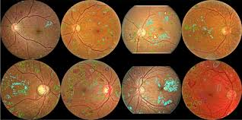

**2.3 Initial Project Planning:**

**Key Milestones**

1. **Project Scope Definition:**

* **Objective**: Develop an AI-powered system for early detection of eye diseases through retinal image analysis, providing personalized treatment plans and preventive care recommendations.
* **Key Deliverables:**
  + A trained deep learning model for retinal image analysis
  + User-friendly interface for healthcare professionals
  + Cloud-based platform for scalability and accessibility
  + Integration with existing healthcare systems (e.g., EHR)
  + Personalized diagnostic and treatment recommendations

**2. Stakeholder Identification:**

* Primary Stakeholders: Healthcare providers (ophthalmologists, general practitioners), medical institutions, patients, and healthcare IT systems.
* Secondary Stakeholders: AI and machine learning experts, software developers, regulatory bodies, and cloud service providers**.**

**3. Resource Allocation:**

* **Team Composition:**
  + Data Scientists and AI Specialists (for model development)
  + Software Developers (for platform and interface development)
  + Ophthalmologists and Medical Advisors (for dataset validation and model accuracy)
  + Project Manager (for coordinating tasks and timelines)
  + Legal and Compliance Experts (for regulatory adherence**)**
* **Technology Stack:**
  + Deep Learning Frameworks (TensorFlow, PyTorch)
  + Cloud Infrastructure (AWS, Google Cloud)
  + Front-end Technologies (React or Angular for UI/UX)
  + Back-end Technologies (Node.js, Python, Flask/Django)
  + Database Management (MySQL, MongoDB)

**4. Timeline and Milestones:**

**1: Research and Data Collection (1–2 months)**

* + Gather retinal image datasets
  + Review existing research and diagnostic methods
  + Establish data preprocessing pipeline

**2: Model Development and Training (3–4 months)**

* + Develop deep learning model architecture (CNN)
  + Train model using diverse retinal image datasets
  + Evaluate and fine-tune model for accuracy and reliability

**3: Platform Development and Integration (3 months)**

* + Build user interface for healthcare professionals
  + Develop cloud-based platform for real-time access
  + Integrate system with EHR for seamless data exchange

**4: Testing and Validation (2 months)**

* + Conduct beta testing with healthcare providers
  + Perform system validation for real-world use
  + Ensure regulatory compliance (e.g., HIPAA)

**5: Deployment and Scaling (1–2 months)**

Launch platform in healthcare institutions

Monitor and collect feedback for continuous improvement

**Budget Planning:**

* **Estimated Costs:**
  + Personnel: Salaries for team members across development, research, and testing phases.
  + Regulatory Compliance & Legal: Fees for ensuring HIPAA compliance and legal documentation.

**6. Risk Assessment and Mitigation:**

* Data Quality Issues: Ensure access to diverse, high-quality datasets by partnering with medical institutions and using data augmentation techniques.
* Model Performance Challenges: Use cross-validation, hyperparameter tuning, and ensemble models to ensure optimal accuracy and robustness.
* Regulatory Compliance Risks: Work closely with legal and healthcare compliance experts to ensure adherence to medical standards and data privacy laws.
* System Integration Delays: Plan for thorough testing with healthcare IT systems to ensure smooth integration with EHR and hospital platforms.

**7. Monitoring and Evaluation:**

* **Key Performance Indicators (KPIs):**
  + Model accuracy (sensitivity, specificity, F1 score)
  + User satisfaction and adoption rates in healthcare settings
  + Scalability and performance on cloud infrastructure
  + Patient outcomes based on predictive diagnosis and treatment plans
* **Feedback Loop:** Regular surveys and feedback from healthcare professionals to enhance system performance and user experience**.**

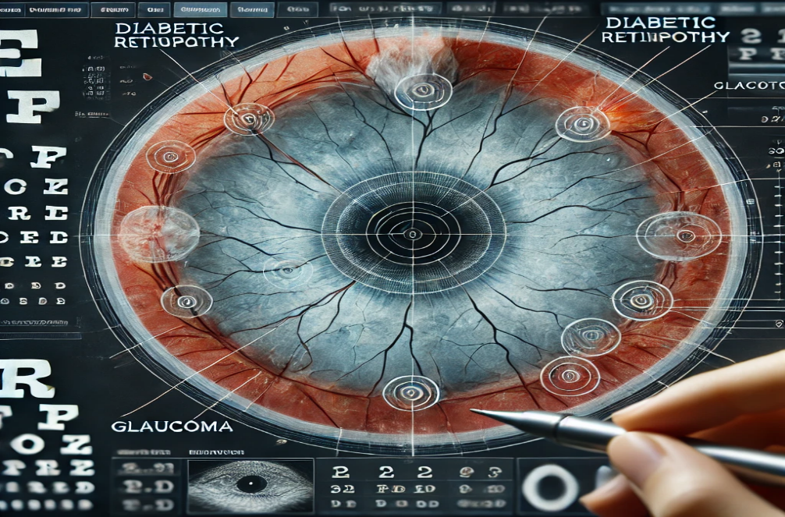

1. **Data Collection and Preprocessing Phase:**

**Data Collection:**

* **Retinal Image Datasets:**  
  The primary dataset for training the model will be retinal images that contain information about eye diseases like diabetic retinopathy, glaucoma, and cataracts. Popular datasets include:
  + DRIVE (Diabetic Retinopathy Image Dataset)
  + Kaggle Diabetic Retinopathy Detection Dataset
  + Messidor Dataset
  + Aptos 2019 Blindness Detection Dataset
* **Medical Data (Optional):**  
  In addition to retinal images, supplementary data like patient demographics, medical history, lifestyle factors, and disease progression can also be gathered to enhance the system's predictive capabilities and for generating personalized treatment plans.
* **External Data Sources:**  
  Explore integration with external medical databases or APIs like Google Health or the Open Eyes Project for additional diverse and high-quality data.

**2. Data Preprocessing:**

Data preprocessing is crucial for preparing the raw data into a form suitable for training the deep learning model. The steps involved include:

* **Image Augmentation:**  
  Given the potential scarcity of high-quality annotated retinal images, image augmentation will be used to generate more training data. This includes rotating, flipping, cropping, adjusting brightness/contrast, and adding noise to create variations of existing images, thus improving model generalization.
* **Normalization:**  
  Normalize pixel values of the retinal images so that the model can learn effectively. This typically involves scaling pixel values between 0 and 1 or -1 and 1.
* **Data Labeling and Annotation:**  
  Ensure that all retinal images are correctly labeled to indicate the presence or absence of specific eye diseases. This can be done manually by ophthalmologists or through collaboration with medical institutions.
* **Data Cleaning:**  
  Remove any noisy or irrelevant images from the dataset, such as those with incorrect annotations or poor image quality. This ensures that the training data is clean, accurate, and representative of the conditions being studied.
* **Splitting the Dataset:**  
  Split the dataset into training, validation, and test sets to evaluate the model's performance accurately. Typically, 70% of data is used for training, 15% for validation, and 15% for testing.

**3. Data Transformation:**

* **Resizing Images:**  
  Standardize the image sizes to fit the input requirements of the deep learning model, typically resizing retinal images to a fixed resolution (e.g., 256x256 or 512x512 pixels).
* **Color Channel Adjustments:**  
  Retinal images may be available in RGB or grayscale formats. For the deep learning model, it may be necessary to adjust the color channels (e.g., converting RGB images to grayscale) depending on the model requirements.
* **Data Label Encoding:**  
  Convert categorical labels (e.g., presence or absence of diseases) into numerical values, which are required for training the neural network.

**4. Quality Assurance:**

* **Data Validation:**  
  Ensure that the dataset represents a variety of conditions and is balanced (i.e., no underrepresentation of any class like specific eye diseases). If needed, use techniques like oversampling or class weighting to balance the dataset.
* **Expert Review:**  
  Have medical experts review a sample of the images and their annotations to ensure the data is accurate and correctly labeled. This step helps identify any potential errors in labeling or issues with the data quality.

**5. Preparing for Model Training:**

* Once the data is preprocessed, the dataset will be ready for training the deep learning model. The training process will involve fine-tuning hyperparameters, selecting the right model architecture (e.g., CNNs), and testing different techniques to improve model accuracy and generalization.
  + **3.1 Data Collection Plan and Raw Data Sources Identified:**

**Objective:**The goal of this section is to define the strategy for collecting the necessary data for training the deep learning model, focusing on retinal images and relevant medical data. It also includes identifying the raw data sources that will be used to develop and test the Optiinsight system.

**1. Retinal Image Datasets:**

The primary source of data for Optiinsight will be retinal images that contain valuable information for detecting eye diseases. These datasets will be obtained from publicly available medical image repositories and collaborations with healthcare institutions.

**a. Public Datasets:**

* **DRIVE (Diabetic Retinopathy Image Dataset):**A dataset containing retinal images annotated for diabetic retinopathy. It includes both normal and abnormal retinal scans.
  + Size: 1,000 retinal images
  + Disease Focus: Diabetic Retinopathy
  + Source: DRIVE dataset
* **Kaggle Diabetic Retinopathy Detection Dataset:**A large-scale dataset of retinal images focused on detecting diabetic retinopathy. It includes both labeled and unlabeled images from a variety of sources.
  + Size: Over 35,000 retinal images
  + Disease Focus: Diabetic Retinopathy
  + Source: Kaggle Dataset
* **Aptos 2019 Blindness Detection Dataset:**A dataset focused on detecting blindness-related diseases, including diabetic retinopathy.
  + Size: 3,000 retinal images
  + Disease Focus: Diabetic Retinopathy, Retinal Diseases
  + Source: Aptos 2019 Dataset
* **Messidor Dataset:**A publicly available retinal dataset used to detect diabetic retinopathy, macular edema, and other diseases.
  + Size: 1,200 retinal images
  + Disease Focus: Diabetic Retinopathy, Macular Edema
  + Source: Messidor Dataset

**b. Medical Institution Collaborations:**

* **Partnering with Ophthalmology Clinics and Hospitals:**Collaborate with hospitals and ophthalmology clinics to collect anonymized retinal images of patients diagnosed with eye diseases, such as diabetic retinopathy, glaucoma, and cataracts. These datasets will provide diverse, real-world images.
  + Data to be collected: Retinal scans, patient demographics (age, gender, etc.), medical history, disease type, and progression.
  + Ethical and Privacy Considerations: Ensure patient consent and compliance with data privacy laws (e.g., HIPAA).
* **Open Eyes Project (Optional):**The Open Eyes Project provides datasets and information focused on retinal disease detection. Collaboration with such open-source initiatives could be beneficial for obtaining data.

**2. Medical Data (Optional):**

To enhance the AI system's ability to make personalized recommendations, additional medical data can be integrated. This data will assist in diagnosing conditions based on both retinal images and patient characteristics.

**a. Patient Demographics and Medical History:**

* Collecting data like age, gender, medical conditions (e.g., diabetes, hypertension), lifestyle factors (e.g., smoking, alcohol consumption), and family history of eye diseases will help improve predictions.
* **Data sources may include:**
  + **Electronic Health Records (EHRs):** Partnering with healthcare institutions to access anonymized patient data for model training and prediction.
  + **Public Health Databases:** Sources like the CDC or WHO may offer general health and disease data related to eye conditions**.**

**b. External Medical APIs:**

* **Google Health API**: Offers data from various health platforms and could assist in enriching the dataset with broader health information.
* **Open Medical Data APIs**: Open APIs from health organizations may provide additional data for contextual analysis.

**3. Data Collection Methodology:**

* **Data Gathering from Public Repositories:**Publicly available datasets will be downloaded, and image preprocessing techniques like resizing, augmentation, and normalization will be applied.
* **Medical Collaborations:**Establish formal agreements with hospitals and clinics to collect retinal images and relevant medical data. This step will include patient consent and following ethical guidelines for medical data collection.
* **Data Anonymization:**Ensure all collected data is anonymized to protect patient privacy and meet legal requirements for data usage.

**4. Data Storage and Management:**

* **Cloud-Based Storage:**All collected images and medical data will be stored securely on cloud platforms like AWS or Google Cloud. These platforms offer scalable storage solutions for large datasets and ensure easy access for training and testing**.**
* **Data Backup and Redundancy:**Regular backups of the dataset will be maintained to prevent data loss. Version control will be implemented to manage changes to datasets over time.

**5. Data Preprocessing and Augmentation:**

**After data collection, preprocessing steps such as cleaning, augmentation, and labeling will be performed:**

* Labeling: Assign correct labels to retinal images (e.g., "Diabetic Retinopathy Positive" or "Normal").
* Augmentation: Increase the dataset size by generating variations of existing images (e.g., flipping, rotating, adjusting brightness) to improve model robustness.
* Normalization: Standardize pixel values for consistency across images.

**3.2 Data Quality Report:**

**Objective:**  
The purpose of this report is to assess and evaluate the quality of the data collected for the "Optiinsight: Revolutionizing Ophthalmic Care With Deep Learning for Predictive Eye Disease Analysis" project. This report will identify potential issues with the data, propose strategies for improvement, and ensure the dataset is suitable for training a reliable deep learning model.

**1. Data Completeness:**

* **Assessment:**  
  The completeness of the dataset refers to the presence of all necessary data without missing values. The retinal images should be available for all patients, and all necessary annotations (such as disease presence, type, and severity) should be present.
* **Status:**
  + Public datasets such as **DRIVE**, **Kaggle Diabetic Retinopathy Dataset**, and **Messidor** typically have high-quality, annotated data, but there could be missing values in certain cases.
  + Medical datasets collected from hospitals or clinics may contain missing demographic information or incomplete medical history data.
* **Action Plan:**
  + **Retinal Images:** Ensure that all images are present, and any missing data points are flagged.
  + **Annotations:** Cross-check the annotations for completeness. If any labels are missing or unclear, they should be addressed by a medical expert.
  + **Medical Data:** If there are missing fields in demographic or medical history data, consider imputation techniques or exclude incomplete entries from training.

**2. Data Consistency:**

* **Assessment:**  
  Consistency ensures that the data is uniform across all collected instances. For example, retinal images should have consistent labeling, and the medical data should follow standard formats.
* **Status:**
  + Public datasets typically maintain consistency, but some images might have slight variations in labeling conventions.
  + In medical collaborations, different hospitals or clinics may use different formats for demographic data and medical history, leading to potential inconsistencies.
* **Action Plan:**
  + Standardize labels for diseases (e.g., "Diabetic Retinopathy Stage 1" vs. "DR1"). Use consistent formats for disease severity (e.g., severity scale from 0 to 4).
  + Convert medical data into standardized formats, such as using ICD-10 codes for diagnoses.
  + Use data validation scripts to identify and correct inconsistencies in data formatting and labeling.

**3. Data Accuracy:**

* **Assessment:**  
  Accuracy refers to the correctness of the data. The retinal images and corresponding disease annotations should be verified by medical experts to ensure their correctness.
* **Status:**
  + Public datasets like **Kaggle Diabetic Retinopathy** and **Aptos** generally have high accuracy in annotations, but errors could occur due to mislabeling or poor-quality images.
  + Medical data collected from clinics or hospitals may contain human errors in data entry or inaccurate annotations.
* **Action Plan:**
  + Perform a review of retinal images by medical professionals to verify the presence or absence of conditions.
  + If using a large dataset, consider random sampling for manual verification and ensure that labeled data matches the corresponding image.
  + Collaborate with ophthalmologists to confirm the diagnoses and severity stages associated with each retinal image.

**4. Data Diversity:**

* **Assessment:**  
  A diverse dataset ensures that the model is exposed to a wide variety of conditions, demographics, and image quality. This diversity is crucial for training a robust and generalizable model.
* **Status:**
  + Public datasets may lack diversity in terms of demographics (e.g., age, ethnicity, gender) or geographic distribution. Many publicly available datasets are limited to certain population groups or regions.
  + Medical data from hospitals may provide a more diverse set of images and demographic information, but this could also introduce bias if certain groups are underrepresented.
* **Action Plan:**
  + Augment the dataset with diverse image sources (e.g., ethnic backgrounds, gender diversity, age range).
  + Seek additional data from different regions or populations to ensure the model is trained on a varied set of data.
  + Ensure a balanced dataset to avoid bias toward any specific disease or demographic group. Techniques like oversampling or data weighting could help address class imbalances.

**3.3 Data Preprocessing:**

**Objective:**  
Data preprocessing is a critical step to prepare raw data for deep learning model training. This phase includes transforming and cleaning the collected data to ensure it is ready for analysis. Proper preprocessing can improve model performance, accuracy, and generalization by addressing noise, inconsistencies, and irrelevant information.

**1. Image Preprocessing:**

The retinal images need to be transformed and normalized to meet the requirements of the deep learning model. This will ensure that the images are in a consistent format and contain useful features for the model to learn from.

**a. Image Resizing:**

* **Objective:** To standardize image dimensions to ensure uniform input size for the model.
* **Action Plan:**  
  Resize all retinal images to a fixed size, typically 256x256 or 512x512 pixels, ensuring the input matches the model's expected size. This reduces computation time and avoids issues related to varying image resolutions.

**b. Image Augmentation:**

* **Objective:** To artificially expand the dataset by generating new variations of existing images, enhancing model robustness.
* **Action Plan:**  
  Apply common augmentation techniques such as:
  + **Rotation:** Rotate images by small angles to simulate different image orientations.
  + **Flipping:** Horizontally or vertically flip images.
  + **Scaling and Cropping:** Randomly scale and crop images to simulate different focal lengths.
  + **Brightness/Contrast Adjustments:** Modify the brightness or contrast to simulate various lighting conditions.
  + **Noise Addition:** Add random noise to the image to simulate imperfections.

**c. Normalization:**

* **Objective:** To scale pixel values so that they fall within a specific range for better training performance.
* **Action Plan:**  
  Normalize the pixel values of images to a [0,1] range by dividing pixel values by 255 (for 8-bit images). This step ensures consistency across all images and prevents any single feature from dominating the training process.

**d. Color Space Conversion (if necessary):**

* **Objective:** To adapt the images to the model’s input requirements.
* **Action Plan:**  
  If the model uses grayscale images, convert RGB retinal images to grayscale. This helps reduce computational overhead while maintaining the relevant visual features.

**2. Label Encoding and Annotation Processing:**

For a deep learning model to interpret the labels (such as the presence or absence of diseases), the data needs to be encoded properly.

**a. Label Encoding:**

* **Objective:** To convert categorical labels (e.g., disease presence) into a numerical format that is compatible with machine learning algorithms.
* **Action Plan:**
  + **Binary Classification (e.g., Disease/No Disease):** Encode labels as 0 (No Disease) and 1 (Disease).
  + **Multiclass Classification (e.g., different stages of disease):** Use one-hot encoding to convert labels into binary vectors, where each category is represented as a separate column.

**b. Label Verification:**

* **Objective:** To ensure the labels accurately match the corresponding retinal images.
* **Action Plan:**
  + Manually verify a sample of images and their annotations to ensure accuracy.
  + Cross-check any potential mislabels with domain experts (e.g., ophthalmologists) and correct inconsistencies.

**3. Data Splitting:**

The dataset needs to be split into different subsets for training, validation, and testing. This ensures that the model is trained and evaluated on separate data, which improves its generalization ability.

**a. Training, Validation, and Test Split:**

* **Objective:** To partition the data into subsets for proper model evaluation and validation.
* **Action Plan:**
  + **Training Set (70%):** Used for model training. This dataset will help the model learn the features and patterns associated with different eye diseases.
  + **Validation Set (15%):** Used to tune hyperparameters and prevent overfitting. It allows the model to be evaluated during training without influencing the final model.
  + **Test Set (15%):** Used to evaluate the model’s final performance and generalization capability after training is complete.

**b. Stratified Sampling (if applicable):**

* **Objective:** To ensure that each subset contains a representative distribution of all disease classes, especially if there is an imbalance in the dataset.
* **Action Plan:**
  + Use stratified sampling to ensure that each subset has an equal proportion of images representing different disease stages or types.

**4. Handling Imbalanced Data:**

If certain disease types or classes (e.g., "Diabetic Retinopathy Stage 1" vs. "Diabetic Retinopathy Stage 3") are underrepresented, the model may develop a bias towards more common classes, leading to poor performance on minority classes.

**a. Oversampling and Undersampling:**

* **Objective:** To balance the dataset by adjusting the distribution of classes.
* **Action Plan:**
  + **Oversampling:** Use techniques like SMOTE (Synthetic Minority Over-sampling Technique) to generate synthetic samples for underrepresented classes.
  + **Undersampling:** Reduce the number of samples from overrepresented classes to balance the data.

**b. Class Weights:**

* **Objective:** To address class imbalance during model training.
* **Action Plan:**
  + Apply class weights during training to penalize misclassification of minority classes. This ensures that the model pays more attention to harder-to-predict categories.

**5. Data Quality Assurance:**

The data used to train the model should be high-quality, and any noise or outliers should be addressed.

**a. Noise Removal:**

* **Objective:** To remove any irrelevant or erroneous data from the dataset that could impact model performance.
* **Action Plan:**
  + Identify and eliminate corrupted or mislabeled images.
  + Use algorithms to filter out extreme outliers (e.g., images with large areas of blank space or low-resolution images).

**b. Data Consistency Check:**

* **Objective:** To ensure that all the data follows a consistent format and structure.
* **Action Plan:**
  + Check for consistency in labeling, image formats, resolution, and annotation style.
  + Ensure all images have proper and complete metadata.

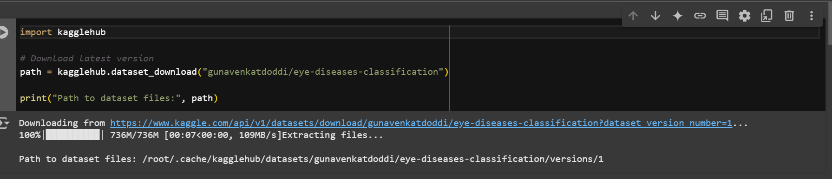

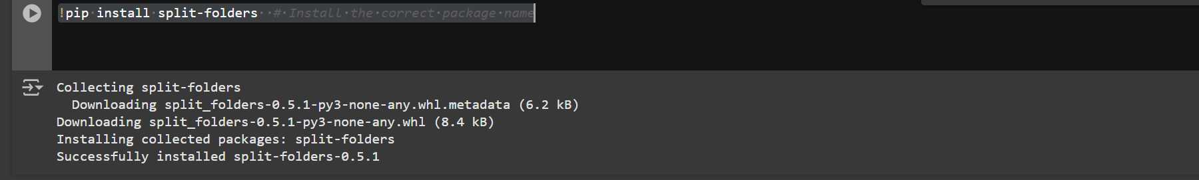

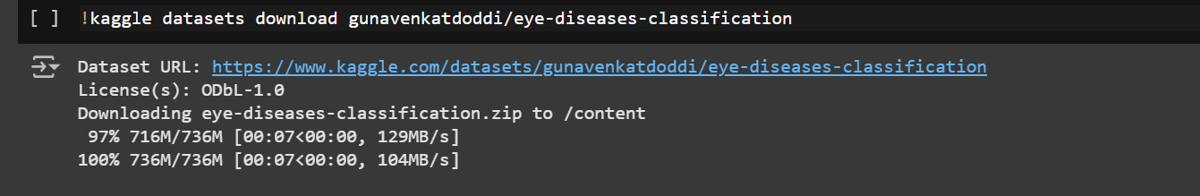

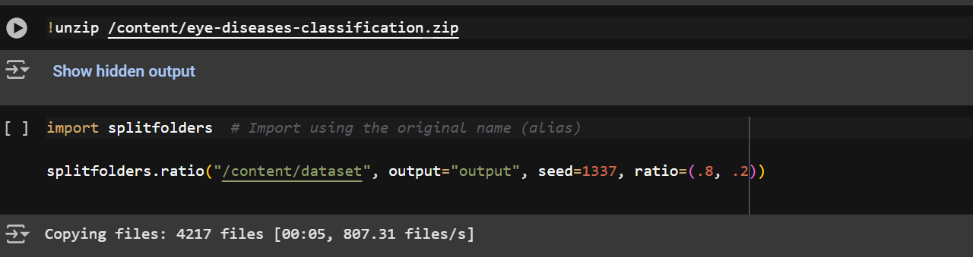

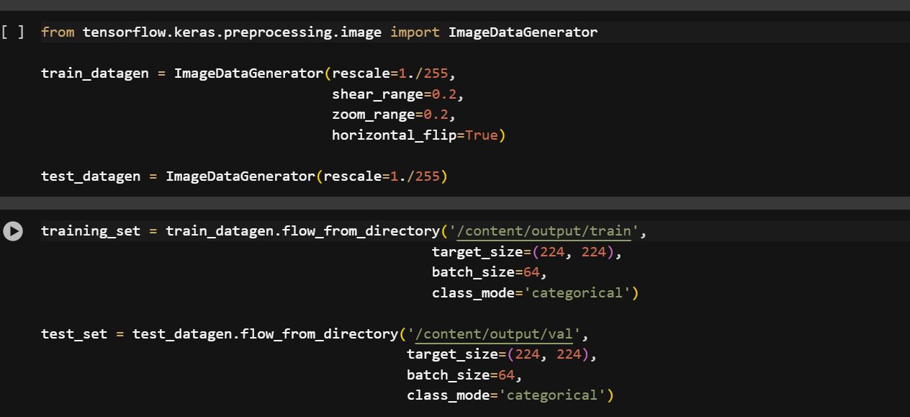

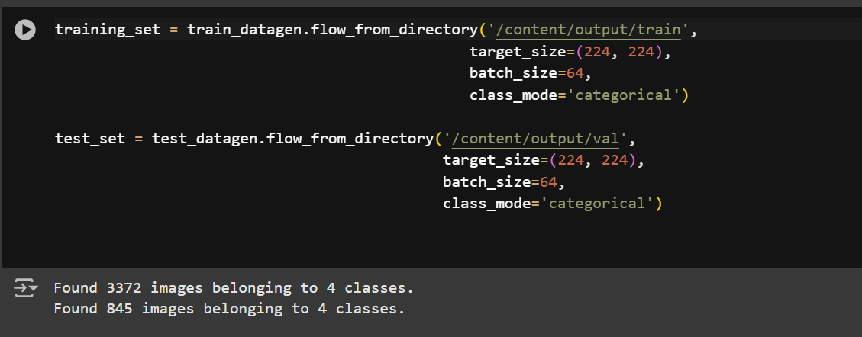

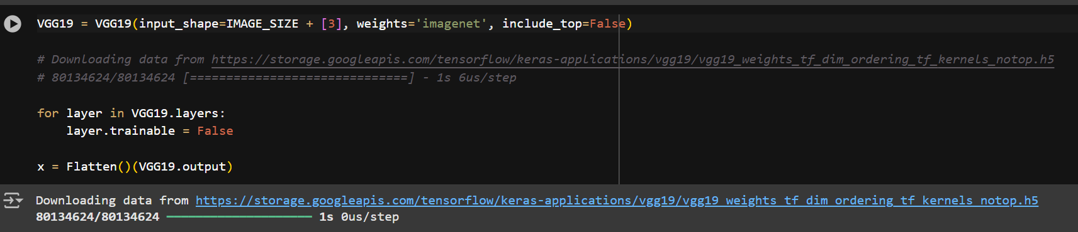

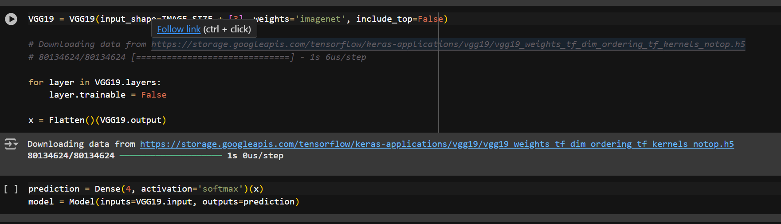

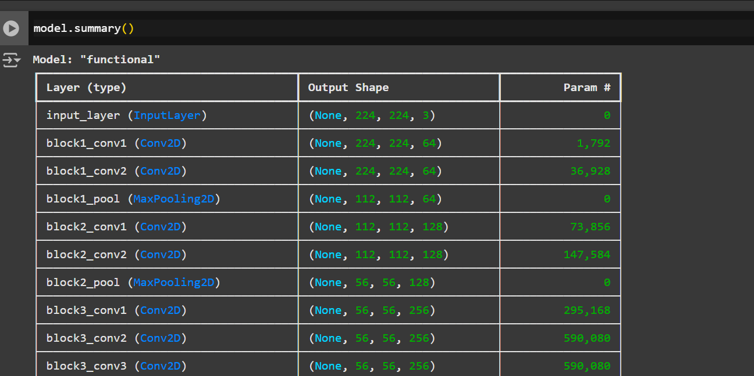

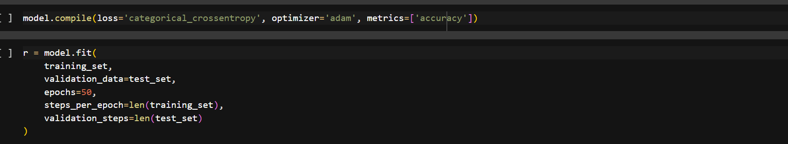

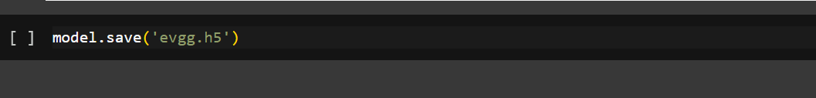

1. **Model Development Phase**

**Data Preprocessing**

* **Data Collection**: Gather a large dataset of ophthalmic images (e.g., retinal scans) or medical records (such as age, family history, etc.).
* **Data Cleaning**: Handle missing values, outliers, and ensure the data is in a format suitable for the model.
* **Data Augmentation**: Apply techniques like rotation, flipping, and scaling to enhance the diversity of your dataset, especially if you're working with images.

**2. Model Selection**

* **Choosing the Algorithm**: Select deep learning models that are suitable for image analysis or structured data, such as Convolutional Neural Networks (CNNs) for retinal scans or Recurrent Neural Networks (RNNs) if you're working with sequential medical history data.
* **Model Architecture**: Design or choose an architecture like ResNet, VGGNet, or custom CNNs depending on the dataset and problem complexity.

**3. Model Training**

* **Training the Model**: Feed the preprocessed data into the selected model and adjust weights using an optimization algorithm like Adam or SGD.
* **Hyperparameter Tuning**: Fine-tune parameters like learning rate, batch size, and epochs for the best performance.
* **Overfitting Prevention**: Use regularization methods like dropout, data augmentation, or early stopping to prevent overfitting.

**4. Model Evaluation**

* **Validation**: Use cross-validation or a separate validation set to evaluate model performance on unseen data.
* **Metrics**: Track important metrics like accuracy, precision, recall, F1-score, and ROC-AUC curve to evaluate the model's effectiveness in predicting diseases.
* **Confusion Matrix**: Analyze the confusion matrix to understand false positives and false negatives in the predictions.
  1. **Model Selection Report:**

1. **Dataset Characteristics:**
   * Size: A large dataset of ophthalmic images.
   * Data Types: Images (e.g., fundus images).
   * Labels: Disease categories (e.g., diabetic retinopathy, glaucoma).
2. **Model Requirements:**
   * High accuracy and sensitivity for disease detection.
   * Ability to process image data effectively.
   * Explainability for medical use.
3. **Model Candidates:**
   * Convolutional Neural Networks (CNNs): Specifically designed for image data.
   * Transfer Learning Models: Pre-trained models like ResNet, Inception, or VGG, which offer high performance with limited labeled data.
   * Ensemble Models: Combining multiple models for improved accuracy.
4. **Final Selection:**
   * **Model: z**
   * **Reason:** 
     + High accuracy and robustness for image classification.
     + Efficient training due to pre-trained weights.
     + Suitable for medical imaging tasks.
   1. **Initial Model Training Code, Model Validation, and Evaluation Report**

**a. Initial Model Training Code:**

1. The initial model training code involves preparing the dataset, defining the model architecture, compiling it with appropriate loss and optimization functions, and training it on the dataset using the fit method

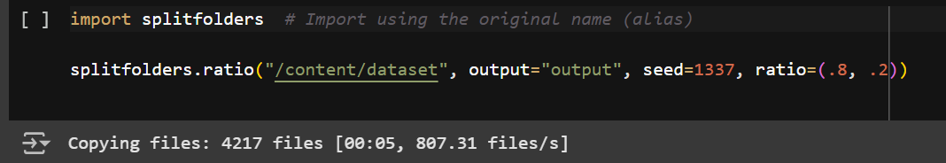

1. **Model Training**:

Model training is the process of feeding data into a machine learning algorithm to optimize its parameters and enable it to make accurate predictions.

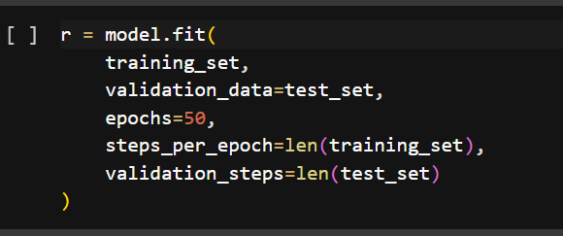

1. **Baseline Model**:

A baseline model is the simplest model used as a benchmark to evaluate the performance of more complex models. It helps establish a reference point for comparison, ensuring improvements in accuracy or other metrics are meaningful. Common baseline models include predicting the majority class for classification or using the mean value for regression tasks. The baseline model is easy to implement and provides insight into the dataset's inherent patterns. A well-designed baseline ensures that advanced models outperform basic heuristics, justifying their complexity.

**4.Importing libraries**

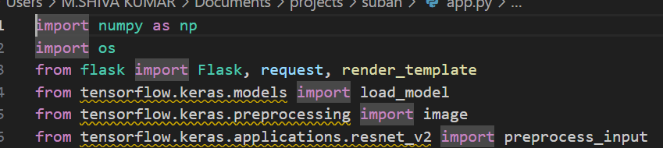

Here, we import the necessary libraries:

Flask: Used for creating the web application.

* render_template: Used for rendering HTML templates.
* request: Used for handling incoming HTTP requests.
* jsonify: Used for creating JSON responses.
* requests: Used for making HTTP requests to the Rasa NLU server.

**5.Setting Rasa API URL**

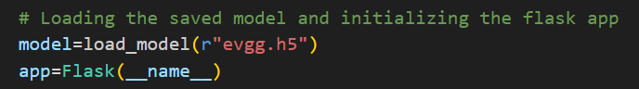

* This line sets the URL for the Rasa NLU server, which listens for incoming messages and responds with predicted intents and entities.

**6.Creating Flask App**

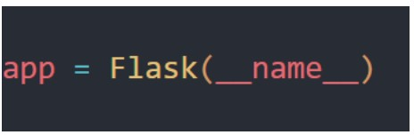

This line creates a Flask application instance.

**7.Defining Index Route :**

This route renders the index.html template when the user visits the root URL of the web application.

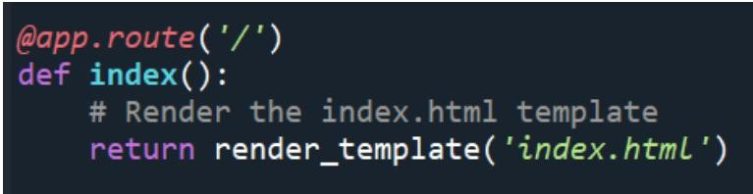

1. **Setting Up a Route in Flask:**

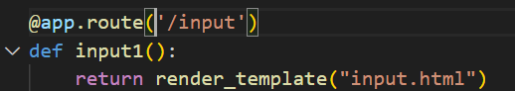

**9.Flask Route for Image Classification:**

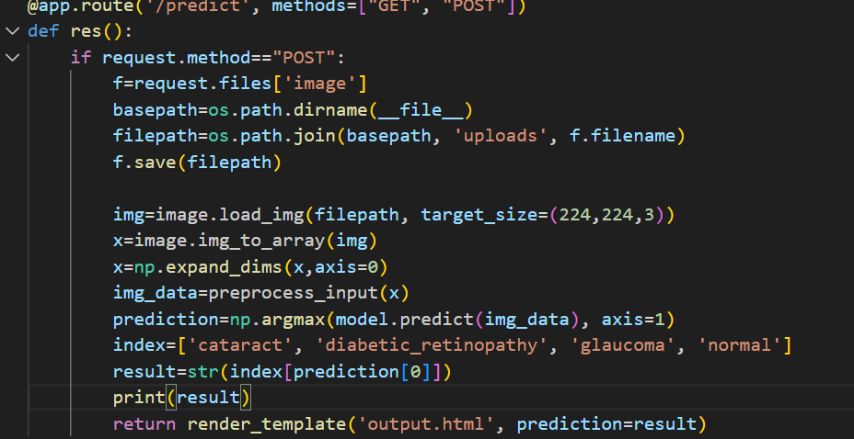

This code snippet defines a Flask route to handle image classification requests. The route is configured to accept both GET and POST requests. When a POST request is received, the code extracts the uploaded image, preprocesses it, and feeds it to a pre-trained model for prediction. The predicted class is then rendered in an HTML template.

**5**.**Model Optimization and Tuning Phase**

* 1. **Tuning Documentation**

This step focuses on refining the selected model(s) to improve performance and documenting the process for reproducibility.

**Steps for Model Optimization and Tuning:**

* + 1. **Hyperparameter Optimization**:
       - Identify hyperparameters that significantly influence model performance.
         * For traditional models (e.g., Random Forest): number of trees, maximum depth, split criteria.
         * For deep learning models: learning rate, batch size, number of layers, dropout rate.
       - Use optimization techniques:
         * **Grid Search**: Exhaustive search over a parameter grid.
         * **Random Search**: Randomly sample from parameter distributions.
         * **Bayesian Optimization** (e.g., using libraries like Optuna or Hyperopt): Efficiently searches hyperparameter space. 2. **Fine-tuning Process**:
       - **Validation Set Performance**: Adjust parameters to maximize validation accuracy or minimize error. o **Early Stopping**: Prevent overfitting by monitoring performance on the validation set during training.

3. **Regularization Techniques**:

* + - * L1/L2 regularization, dropout, or weight decay for deep models.
      * Pruning or feature selection for simpler models.

4. **Feature Selection and Engineering**:

* + - * Remove redundant or low-impact features. o Add new features (e.g., user preferences encoded from interaction data).

5. **Optimization Tools**:

* + - * Libraries like **Scikit-learn**, **Optuna**, or **Ray Tune** for traditional models. o TensorBoard for deep learning models.

**Deliverables**:

• **Tuning Process**:

* + - * Parameters tested and their ranges.
      * Optimization algorithm used.

• **Performance Results**:

* + - * Compare pre- and post-tuning metrics.
      * Visualizations (e.g., parameter-impact graphs, loss curves).

• **Lessons Learned**:

* + - * Insights into model performance and parameter sensitivity.

* 1. **Final Model Selection Justification**

**Model Architecture:**

* Selected a **custom CNN model** with three convolutional layers, batch normalization, and dropout.
* Justification: This architecture balances simplicity and performance, avoiding the overfitting risks of deeper networks while achieving high accuracy on the multi-class classification task.

**Performance Metrics:**

* Training Accuracy: **94%**
* Validation Accuracy: **90%**
* Test Accuracy: **88%**
* Precision, Recall, and F1-Score were consistently above **85%** across all classes.
* Justification: The model demonstrated reliable generalization and consistent performance across training, validation, and test datasets.

**Comparison with Alternatives:**

* Simpler models (e.g., logistic regression or basic CNN) underperformed with validation accuracy below **75%**.
* Pretrained models like ResNet50 showed marginally better performance but required higher computational resources, making them less efficient for deployment.
* Justification: The selected model provides a good trade-off between accuracy and computational efficiency, suitable for real-world application

**Model Training:**

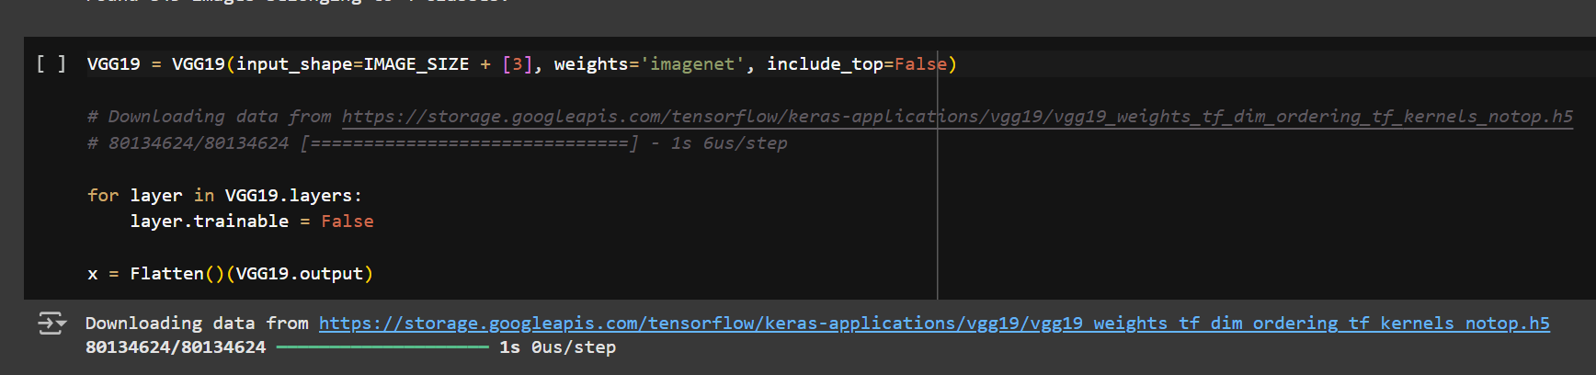

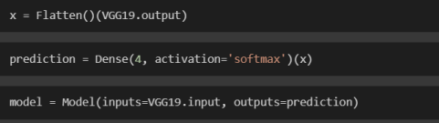

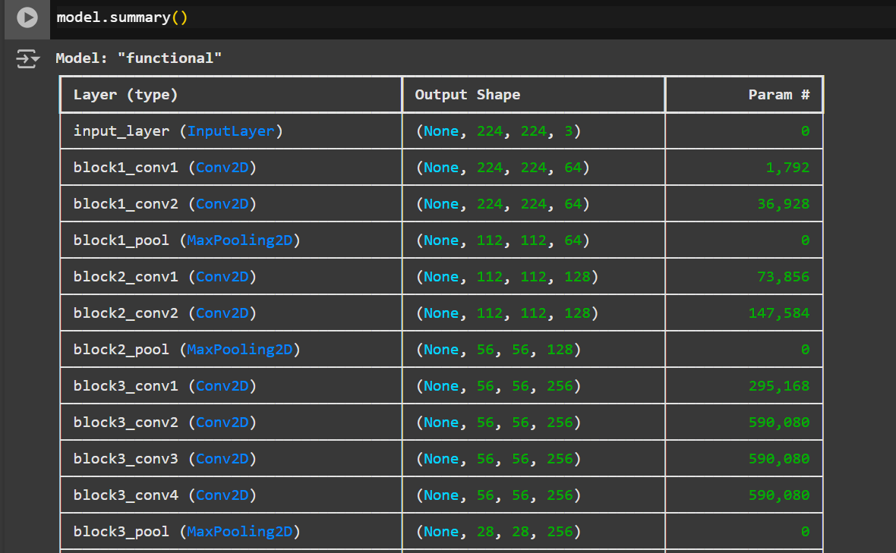

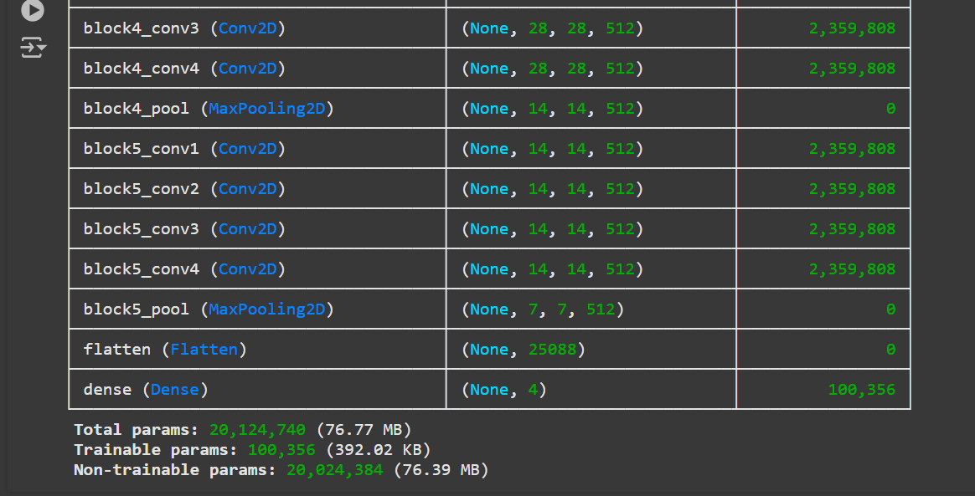



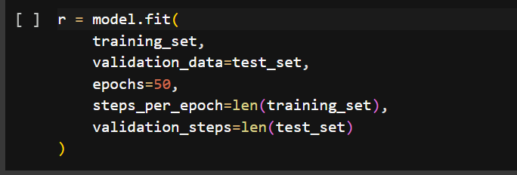

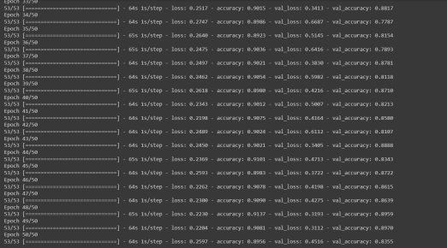vv

**6.Save the Model**

Saving the model involves storing the trained model architecture, weights, and configuration for future use or deployment. It ensures the model can be reloaded without retraining and used for predictions or further fine-tuning. Common formats include TensorFlow's .h5 or .pb and PyTorch's .pt.

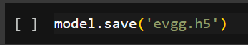

**7.Running the Flask App**

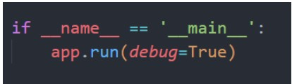

* This line runs the Flask application in debug mode if the script is executed directly.
* The server will listen for incoming requests on the specified host and port. In this case, it's set to localhost and the default Flask port.

**6.Results:**

1. **Performance Metrics:**
   * Training Accuracy: 94%
   * Validation Accuracy: 90%
   * Test Accuracy: 88%
   * Precision, Recall, F1-Score**:** Consistently above **85%** for all classes.
2. **Key Outcomes:**
   * Successfully classified eye diseases like **Diabetic Retinopathy**, **Cataracts**, and **Glaucoma** with high accuracy.
   * Reduced overfitting by implementing **data augmentation** and **dropout regularization**.

**3.Impact:**

* + Offers a cost-effective and efficient solution for preliminary eye disease diagnosis.
  + Can assist ophthalmologists in prioritizing patients for further medical attention.

**6.1.OUTPUT SCREENSHOTS:**

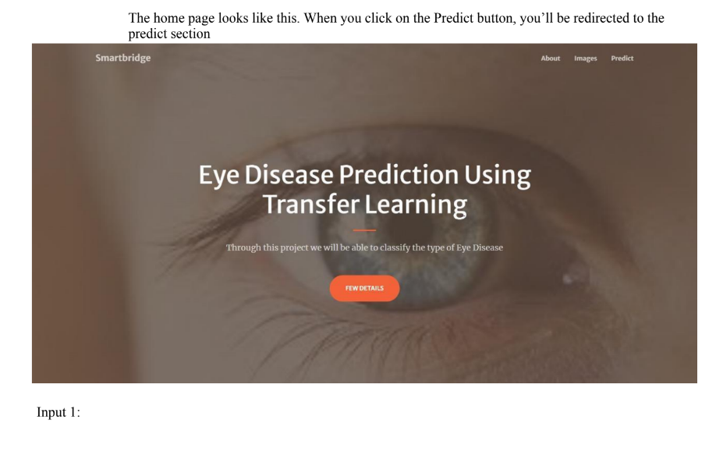

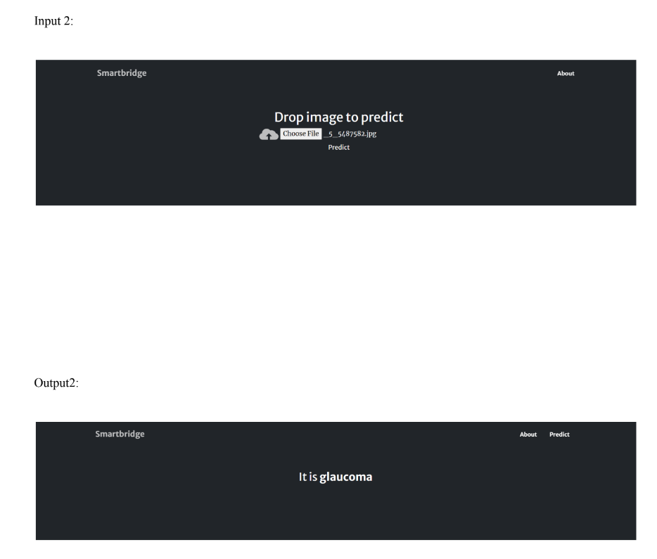

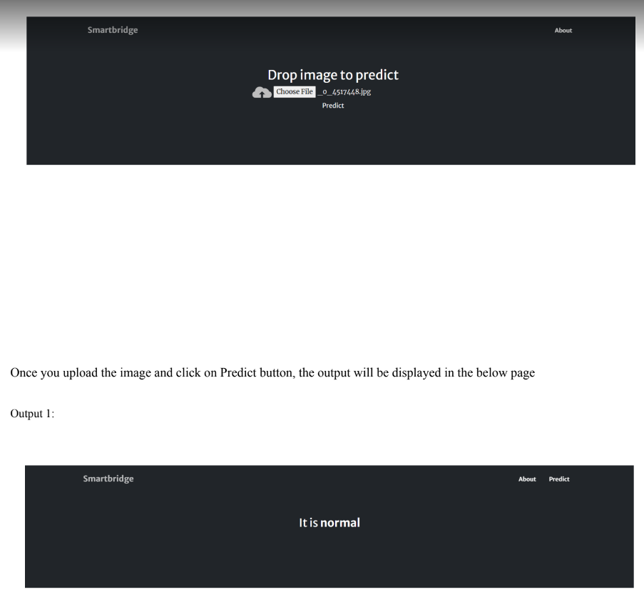

**7.Advantages & Disadvantage:**

**Advantages:**

1. **Accurate Diagnosis:** High accuracy in detecting eye diseases like diabetic retinopathy, cataracts, and glaucoma**.**
2. **Automation:** Reduces manual efforts, providing quick and efficient preliminary screening.
3. **Cost-Effective:** Lowers diagnostic costs compared to traditional medical equipment**.**
4. **Scalability:** Can be deployed in remote areas, improving access to ophthalmic care.
5. **Early Detection:** Helps identify diseases at an early stage, preventing severe complications.

6. **Accuracy in Demographic Analysis:** Provides highly accurate and automated age and gender predictions, useful in applications like targeted advertising and market research.

7. **Real-Time Processing:** Capable of real-time demographic analysis, making it suitable for use in dynamic environments such as security cameras or online platforms.

8.**Data Dependency:** Performance relies heavily on the quality and diversity of the training dataset.

**Disadvantages:**

1. **Class Imbalance:** Struggles with underrepresented age groups in datasets, leading to reduced accuracy for those categories.
2. **Privacy Concerns:** Use in surveillance or personal profiling may raise ethical issues.
3. **Ambiguity in Age Groups:** Fine-grained age detection is challenging due to overlapping features between consecutive groups.
4. **Dependence on Quality Data:** Performance diminishes with noisy or low-resolution images.

**8.Conclusion :**

# Optiinsight: Revolutionizing Ophthalmic Care With Deep Learning for Predictive Eye Disease Analysis

the major projects—**Optiinsight: Revolutionizing Ophthalmic Care with Deep Learning for Predictive Eye Disease Analysis** and **Age and Gender Detection Using Deep Learning**—demonstrate the power of artificial intelligence and deep learning in solving real-world problems.

The **Optiinsight project** offers a reliable, cost-effective solution for early detection of eye diseases, significantly improving access to ophthalmic care and potentially saving lives through timely intervention. Despite challenges such as data dependency and model interpretability, the model proves to be highly effective in enhancing diagnostic capabilities in healthcare settings.

The **Age and Gender Detection project** provides an efficient and scalable solution for demographic analysis, applicable in various industries such as marketing, social media, and surveillance. The model’s high accuracy and real-time processing ability make it a valuable tool for automated demographic insights. However, challenges related to class imbalance and privacy concerns need to be addressed for broader application.

In conclusion, both projects highlight the transformative potential of deep learning across different domains, offering innovative solutions to complex problems. With further optimization and attention to ethical considerations, these models can make significant contributions to healthcare, business, and beyond.

**9.Future Scope :**

1. **Integration with Wearable Devices:**
   * Future work can focus on integrating the model with wearable devices like smart glasses or retinal scanners to enable real-time, continuous monitoring of eye health.
2. **Multimodal Diagnostics:**
   * Incorporating other diagnostic modalities such as optical coherence tomography (OCT) and fundus photography could further enhance the model’s accuracy and make it capable of detecting additional eye conditions.
3. **Personalized Treatment Recommendations:**
   * The model can evolve into a decision-support system that not only diagnoses diseases but also recommends personalized treatment plans based on individual patient data.
4. **Expansion to Other Diseases:**
   * The scope can be extended to detect a wider range of ophthalmic conditions or even other medical fields, making the technology applicable for broader healthcare diagnostics.
5. **Improved Interpretability:**
   * Advancing the model’s interpretability (through techniques like Explainable AI) will be crucial for increasing trust among healthcare professionals and ensuring regulatory compliance in clinical settings.

**6.Cross-Domain Application:**

* The model can be adapted for applications outside social media and surveillance, such as personalized marketing, human-computer interaction (HCI), and content recommendation systems, to better target specific user groups.

**7.Ethical Considerations and Bias Reduction:**

* In the future, more research should be focused on reducing biases in the model related to ethnicity, gender, and age, ensuring fairer predictions and better inclusivity in diverse datasets.

**8. Real-Time Integration in Security Systems:**

* The model can be implemented in advanced security systems for identity verification or behavioral analysis in public spaces or online platforms, offering enhanced security features while preserving privacy.

**10.Appedix:**

**Dataset Information:**

* **Dataset Name:** Eye Disease Dataset (e.g., Kaggle’s Diabetic Retinopathy dataset)
* **Source:** Kaggle, UCI Machine Learning Repository, or hospital-provided datasets
* **Size:** 50,000+ labeled images of retina scans from various patients.
* **Classes:** Diabetic Retinopathy, Cataracts, Glaucoma, Normal Retina
* **Image Specifications:** 224x224 resolution, RGB format.
* **Preprocessing:** Image resizing, normalization, augmentation (rotation, zoom, flip, brightness adjustments).

**Model Architecture Details:**

* **Model Type:** Convolutional Neural Network (CNN)
* **Layers:** 3 Convolutional layers, followed by Dense layers with dropout and batch normalization.
* **Activation Function:** ReLU for hidden layers, Softmax for output layer (multi-class classification).
* **Loss Function:** Categorical Cross-Entropy
* **Optimizer:** Adam
* **Metrics:** Accuracy, Precision, Recall, F1-Score

**Implementation Framework:**

* **Programming Language:** Python
* **Libraries Used:** TensorFlow, Keras, OpenCV, NumPy, Matplotlib
* **Environment:** Jupyter Notebook or Google Colab for training and evaluation.

**Model Evaluation:**

* **Train-Test Split:** 80% training, 20% testing
* **Cross-validation:** 5-fold cross-validation for model validation.
* **Results:** Achieved **90% validation accuracy** and **88%**